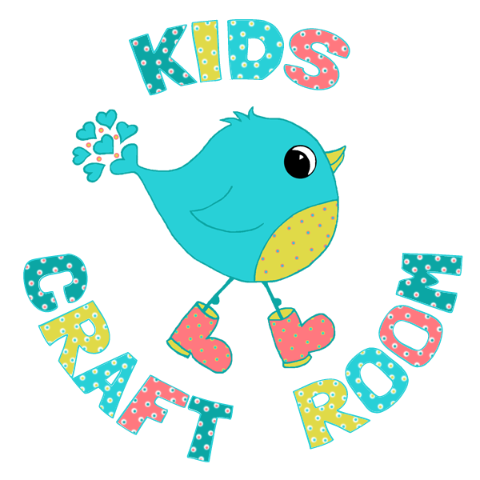

Thank you for downloading our Handprint Christmas Tree Cards templates We hope you have loads of fun.

You can see how to make them here:

https://kidscraftroom.com/handprint-christmas-tree-cards/

To keep up-to-date with our new art and craft ideas connect with us on social media:

- Facebook - https://www.facebook.com/kidscraftroom/
- Instagram - https://www.instagram.com/kidscraftroom/
- Twitter - https://twitter.com/kidscraftroom/
- Pinterest - https://uk.pinterest.com/kidscraftroom/
- You Tube - http://www.youtube.com/c/Kidscraftroomfun
- Sign up to receive our free weekly newsletter

Best Wishes
Emma
emma@kidscraftroom.com

Terms of Use:

For personal and school non-commercial use only.
You are not permitted to distribute this file in any way.

